Welcome!!
Emerald Downs Live Model Horse Show
March 23, 2024

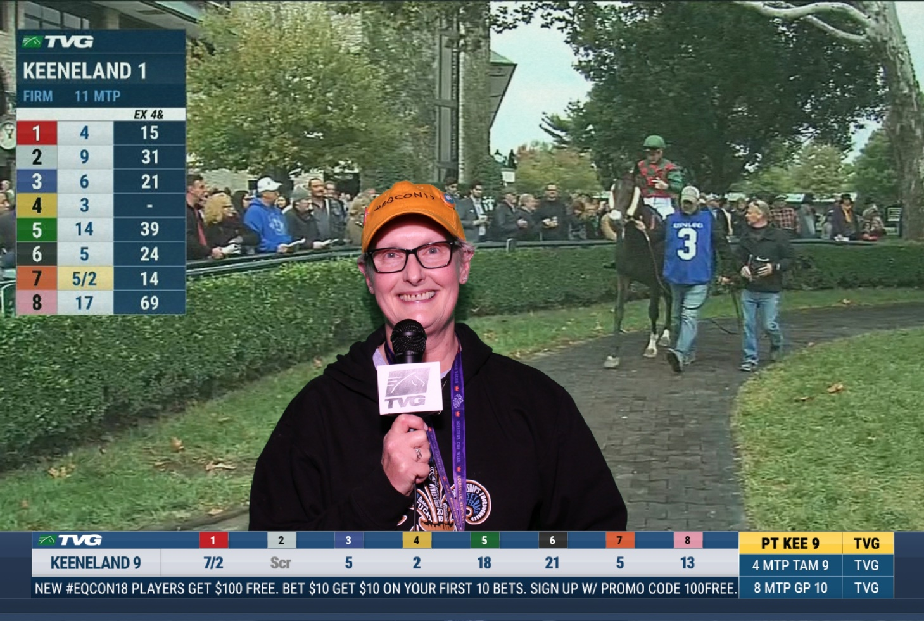

OF Plastic

Foals
1. Light/gaited
2. Sport/WB
3. Stock
4. Draft/pony
5. Other pure/part
Champ/Reserve

Stock Breeds
1. QH
2. Appaloosa
3. Paint
4. Mustang
5. Other pure/part
Champ/Reserve

Light Breeds
1. Arab
2. Part Arab/NSH
3. ASB
4. TWH
5. MFT/other gaited
6. Old World Spanish
7. New World Spanish
8. Morgans
9. Other pure/part
Champ/Reserve

Sport Breeds
1. TB/Stbd
2. European WB
3. All Other WB
4. Sporthorses
5. Carriage/Friesian
6. Other pure/part
Champ/Reserve

Draft Breeds
1. British Draft
2. European Draft
3. American Draft
4. Gypsy Vanners
5. Other pure/part
Champ/Reserve

Pony Breeds
1. British Ponies
2. European (incl. Australia)
3. American Ponies
4. Mini Horse
5. Other pure/part
Champ/Reserve

Other Equine
1. Mule
2. Donkey
3. Zebra/Exotic
4. Other pure/part
Champ/Reserve

Overall OF Plastic Champ/Reserve/HM

OF Stone

Foals
1. QH
2. Appaloosa
3. Paint
4. Light/Gaited
5. Other pure/part
Champ/Reserve

Stock Breeds
1. QH
2. Appaloosa
3. Paint
4. Mustang
5. Other pure/part
Champ/Reserve

Light Breeds
1. Arab
2. Part Arab/NSH
3. ASB/TWH
4. All Spanish
5. Morgan
6. Other pure/part
Champ/Reserve

Sport Breeds
1. TB/Stbd
2. European WB
3. All Other WB
4. Sporthorses
5. Carriage/Friesian
6. Other pure/part
Champ/Reserve

Draft Breeds
1. British Draft
2. European Draft
3. American Draft
4. Gypsy Vanners
5. Other pure/part
Champ/Reserve

Pony Breeds
1. British Ponies
2. European (incl. Australia)
3. American Ponies
4. Other pure/part
Champ/Reserve

Other Equine
1. Mule/Donkey
2. Zebra/Exotic
3 Other pure/part
Champ/Reserve

Overall OF Stone Champ/Reserve/HM

OF Plastic Mini
(All makes, all small sizes)

Foals
1. Light/gaited
2. Sport/WB
3. Stock
4. Draft/Pony
5. Other
Champ/Reserve

Stock Breeds
1. QH
2. Paint
3. Appaloosa
4. Mustang
5. Other pure/part
Champ/Reserve

Light Breeds
1. Arab
2. Part Arab/NSH
3. ASB/TWH
4. MFT/Other gaited
5. Old World Spanish
6. New World Spanish
7. Morgans
8. Other pure/part
Champ/Reserve

Sport Breeds
1. TB/Stbd
2. European WB
3. All Other WB
4. Sporthorses
5. Carriage/Friesian
6. Other pure/part
Champ/Reserve

Draft Breeds
1. British Draft
2. European Draft
3. American Draft
4. Other pure/part
Champ/Reserve

Pony Breeds
1. British Ponies
2. European (incl. Australia)
3. American Ponies
4. Mini Horse
5. Other pure/part
Champ/Reserve

Other Equine
1. Mule
2. Donkey
3. Zebra/Exotic
4. Other pure/part
Champ/Reserve

Overall OF Plastic Mini Champ/Reserve/HM

Collectibility (Breyer and Stone only, all sizes)

Breyer Vintage Unrealistic (up to 1990)
1. Woodgrain
2. Gold Charm/Florentine
3. Copenhagen/Wedgewood
4. Red Roan/Charcoal
5. Other Unrealistic Color
Champ/Reserve

Breyer Modern Unrealistic (1991 to present)
1. Woodgrain
2. Gold Charm/Florentine
3. Copenhagen/Wedgewood
4. Red Roan/Charcoal
5. Silver Filigree
6. Design/Scene
7. Translucent
8. Other Unrealistic Color
Champ/Reserve

Breyer Realistic Color
1. 1950-1969
2. 1970-1989
3. 1990-2009
4. 2010-Present
Champ/Reserve

Stone Vintage Unrealistic (before 2000)
1. Woodgrain
2. Gemstone Colors
3. Other Unrealistic Color
Champ/Reserve

Stone Modern Unrealistic (2001 to present)
1. Woodgrain
2. Gemstone Colors
3. Design/Scene
4. Translucent
5. Other Unrealistic Color
Champ/Reserve

Stone Realistic Color
1. 1996-2005
2. 2006-2015
3. 2016-Present
Champ/Reserve

Breyer/Stone OOAK
1. Light/Gaited
2. Stock
3. All Spanish
4. Sport/WB
5. Draft/Pony
6. All Foals
Champ/Reserve

Fantasy
1. Unicorns
2. Pegasus
3. Other equid fantasy
Champ/Reserve

Miscellaneous
1. Lamps/Clocks/Music Boxes
2. Keychains (SM only)
Champ/Reserve

Overall Collectibility Champ/Reserve/HM

Custom Halter
(All Sizes)

Foals
1. Light/gaited
2. Sport/WB
3. Stock
4. Draft/pony
5. Other pure/part
Champ/Reserve
Stock Breeds
1. QH
2. Paint
3. Appaloosa
4. Mustang
5. Other pure/part
Champ/Reserve

Light Breeds
1. Arab
2. Part Arab/NSH
3. ASB/TWH
4. MFT/Other gaited
5. Old World Spanish
6. New World Spanish
7. Morgans
8. Other pure/part
Champ/Reserve

Sport Breeds
1. TB/Stbd
2. European WB
3. All Other WB
4. Sporthorses
5. Carriage/Friesian
6. Other pure/part
Champ/Reserve

Miscellaneous Breeds
1. British Draft
2. European Draft
3. American Draft
4. Other Pure/Part Draft
5. British Pony
6. European Pony
7. American Pony
8. Other Pure/Part Pony
9. Mule/Donkey
10. Zebra/Exotic
Champ/Reserve

Fantasy
1. Solid Color Fantasy
2. Pattern Fantasy
3. Deco Fantasy
Champ/Reserve
Workmanship
1. Bay/Brown
2. Chestnut/Sorrel
3. All Grey
4. Tobiano
5. Other Pinto
6. Appaloosa
7. Palomino/Buckskin
8. Dun/Grulla
9. Roan
10. Other Color
11. Unrealistic Color
Champ/Reserve

Overall Custom Halter Champ/Reserve/HM

AR/Original Sculpture
(All Sizes)

Foals
1. Light/gaited
2. Sport/WB
3. Stock
4. Draft/pony
5. Other pure/part
Champ/Reserve

Stock Breeds
1. QH
2. Paint
3. Appaloosa
4. Mustang
5. Other pure/part
Champ/Reserve

Light Breeds
1. Arab
2. Part Arab/NSH
3. ASB/TWH/MFT
4. Spanish
5. Other pure/part
Champ/Reserve

Sport Breeds
1. TB/Stbd
2. European WB
3. All Other WB
4. Sporthorses
5. Carriage/Friesian
6. Other pure/part
Champ/Reserve

Miscellaneous Breeds
1. British Draft
2. European Draft
3. Other Pure/Part Draft
4. British Pony
5. European Pony
6. American Pony
7. Other Pure/Part Pony
8. Mule/Donkey
9. Zebra/Exotic
Champ/Reserve

Fantasy/Medallions
1. Solid Color Fantasy
2. Pattern Fantasy
3. Deco Fantasy
4. Solid Color Medallions
5. Pattern Medallions
6. Deco Medallions
Champ/Reserve

Workmanship
1. Bay/Brown
2. Chestnut/Sorrel
3. All Grey
4. Tobiano
5. Other Pinto
6. Appaloosa
7. Palomino/Buckskin
8. Dun/Grulla
9. Roan
10. Other Color
11. Unrealistic Color
Champ/Reserve

Overall AR/Original Sculpture
Champ/Reserve/HM

OF/CM Performance
(All Sizes)

Other Performance
1. Harness
2. Arab Costume
3. Parade
4. Other Costume
5. Other Performance
6. Scene
Champ/Reserve

English Performance
1. Hunter/Jumper/Cross Country
2. Dressage
3. English Games
4. English Trail (arena and natural)
5. Huntseat
6. Saddleseat/Gaited
7. Other
Champ/Reserve

Western Performance
1. Stock Work
2. Western Games
3. Western Trail (arena and natural)
4. Western Pleasure
5. Other
Champ/Reserve

Overall Performance Champ/Reserve

